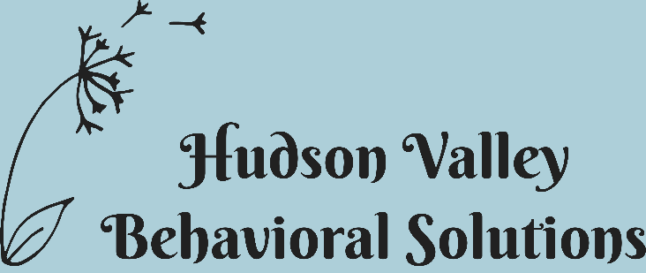

Class Descriptions

* All classes are an hour long. Therapists will provide a feedback form that details the topics covered in the class. Gamer’s Club uses a self-management data collection systemAsk staff for a topic sheet that details the month’s topics.

Mondays: 5pm to 6pm--Preschool/Kindergarten Social Skills Class--This group focuses on a thematic lesson. A concept is presented at the beginning of class--typically revolving around a seasonal event--and all activities are based on this theme. Activities include small group discussion and listener comprehension, arts and crafts, turn taking, social language and behavior.

Wednesdays: 5pm to 6pm--School Age Social Skills Class--This group provides instruction on conversation and friendship development and maintenance. Skills are presented and opportunities are provided for practice and feedback. Activities include interesting games that are age-appropriate and enticing as well as providing opportunities to practice skills that may be hard such as losing and complimenting others when you are not doing as well as you would like.

Wednesdays: 6pm to 7pm—Girls’ Social Skills Class--This group is for middle school and high school aged girls. It focuses on sensitive topics specific to pre-adolescent and adolescent development. Topics are introduced and discussed using young adult novels. The character’s actions, feelings and decisions are discussed. This class does include discussions in dating, relationships and teenage behaviors.

Thursdays: 5pm to 6pm-- Gamers' Club--Just like Younger Gamers', this class is designed to address social skills using video games. Children learn to address peers appropriately, ask and answer questions, use coping skills when disappointed and make positive self-statements. Children are expected to be aware of their own behavior as they learn to self-manage by taking their own data and reflect on their actions. Accuracy is compared to instructor's data.

